Lab Module 6 and 7: Mitosis, Cell Cycle, and DNA Processing (Chapters 6 and 9)
Name: Adriana Ramos
Introduction
One main tenet of the cell theory is that “All cells arise from preexisting cells”. This happens through the process of cell division in which new cells are formed when a “parent cell” divides itself into two new “daughter cells”. In prokaryotes and single-celled eukaryotes, cell division is essential for reproduction and continued existence of a species (although the specifics of the process differ somewhat between these two groups of organisms). In multicellular, eukaryotic organisms, cell division is necessary for growth of the organism and for the replacement of damaged or worn out cells.
In most Eukaryotic organisms, reproduction is “sexual” meaning that offspring are produced by the union of two sex cells (gametes), specifically an egg cell and a sperm cell. When these two cells unite, (fertilization) the resulting cell is called a zygote. This zygote then undergoes many cell divisions (growth) to eventually produce the multicellular offspring.
The “life cycle” of a cell may be thought of as being from the time a cell is produced by division of a parent cell until the time it undergoes cell division to produce two new daughter cells. This cycle is called the “cell cycle” and is shown in a diagram in your textbook. The cell cycle is a continuous process but has been divided into different phases by scientists for better understanding of the various events that take place. These phases consist of interphase (including G1, S, and G2), mitosis (division of the nucleus including prophase, metaphase, anaphase, and telophase), and cytokinesis (division of the cytoplasm).

Learning Outcomes
Upon successful completion of this lab, you should be able to:
1. Define/explain each of the following terms: cell cycle, mitosis, cytokinesis, chromosome, DNA, sister chromatid, chromatin, centromere, nuclear membrane, spindle (microtubules), and centrosomes.
2. Demonstrate and explain mitosis using chromosome models.
3. Identify the stages of the cell cycle, including all stages of interphase and the mitotic phase.
4. Distinguish between mitosis and cytokinesis.
5. Identify the processes involved in nuclear and cell division.
6. Understand the regulatory roles of the cell cycle checkpoints. Understand the consequences of a failed checkpoint.
7. Understand the roles and consequences of failures of oncogenes and tumor-suppressor genes.

PART A: Observation of the phases of mitosis in Onion Root Cells

Materials:
Prepared slide of an onion root tip
Microscope

- Go to the virtual microscope lab:
http://www.ncbionetwork.org/iet/microscope/
- Click on Explore
- Go to “plant cells”
- Choose onion root tip
- Find cells in each phase of the cell cycle and mitosis

Example Images:

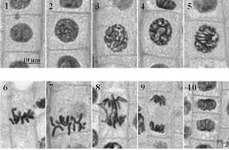
1,2 Interphase
3,4,5 Prophase/Prometaphase
6,7 Metaphase
8 Anaphase
9 Telophase
10 End of Telophase (cytokinesis) formation of daughter cells.

In your drawings Label the pertinent parts present on each drawing including the:
cell wall, cytoplasm, nucleus, chromatin, nuclear membrane (note if it is dissolving or forming), spindle fibers, poles (these are regions, not structures), metaphase plate, sister chromatids (also note when they are pulled apart), chromosomes.

Drawings of six phases of the cell cycle:

Interphase | Prophase | Metaphase
Anaphase | Telophase | Daughter Cells

PART B: Regulation of the Cell Cycle
Access the following url: http://www.hhmi.org/biointeractive/eukaryotic-cell-cycle-and-cancer read the Summary, download and print the Overview Worksheet, (right side of the screen) and the click on “Start Click and Learn” link to access the interactive lesson on the Eukaryotic Cell Cycle and Cancer.

Complete the Overview Worksheet and answer the questions below:

Name 3 specific actions that occur in prophase.

What is the cell doing during G1? S? G2?

What do different cell cycle checkpoints look for?

What is apoptosis? What purpose does it serve?

What is the difference between an oncogene, proto-oncogene, and a tumor suppressor gene?

Can you draw a cell undergoing mitosis?

Part C: DNA Processing
Learning Outcomes
Upon successful completion of this lab, you should be able to demonstrate:
- An understanding of the complementary and antiparallel structure of the double-stranded DNA molecule.
- The process of DNA replication, including names of all enzymes, structures, and the overall procedure. Be able to distinguish between processes of the leading vs lagging strands, and understand how these processes relate to the anti-parallel structure of DNA.
- An understanding of the process and products of transcription.
- An understanding of the process and products of translation, including the ability to translate a messenger RNA to produce a polypeptide (protein).

Part 1: DNA Structure and Replication

A DNA molecule is made of two strands that “complement” each other in the sense that the molecules that compose the strands fit together and bind to each other, creating a double-stranded molecule that looks much like a long, twisted ladder. Each side rail of the DNA ladder is composed of alternating sugar and phosphate groups. The two sides of the ladder are not identical, but are complementary. These two backbones are bonded to each other across pairs of protruding bases, each bonded pair forming one “rung,” or cross member. The four DNA bases are adenine (A), thymine (T), cytosine (C), and guanine (G). Because of their shape and charge, the two bases that compose a pair always bond together: A always binds with T, and C always binds with G.

Your instructor might give you an activity to explore the molecular structure of DNA using puzzles, models, or pen-and-paper exercises. Make sure you use these activities to reinforce your understanding of the complimentary and antiparallel structure of DNA.

The particular sequence of bases along the DNA molecule determines the genetic code. Therefore, if the two complementary strands of DNA were pulled apart, you could infer the order of the bases in one strand from the bases in the other, complementary strand. For example, if one strand has a region with the sequence AGTGCCT, then the sequence of the complementary strand would be TCACGGA.

Question 1: fill in the blanks below to create a complimentary and antiparallel sequence of DNA:

DNA 3’- G _ T G A _ T _ G A C _ A _ T -5’ Coding
... _ G A _ _ G _ A _ _ G T _ C _ ... Template

In order for an organism to grow, develop, and maintain its health, cells must reproduce themselves by dividing to produce two new daughter cells, each with the full complement of DNA as found in the original cell. DNA replication is the copying of DNA that occurs before cell division can take place (see ‘DNA replication’ Figure 1 below).

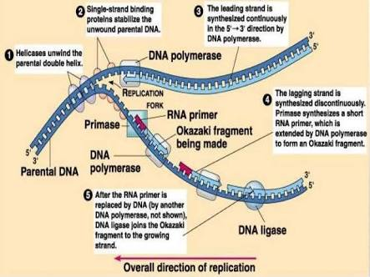

Figure 1. DNA Replication. The copying of DNA.

- To learn more about this process of DNA replication, watch the following video:

https://www.youtube.com/watch?v=TNKWgcFPHqw

- After you have gained an understanding of DNA replication, complete the following diagram using the following terminology list:

Helicase
RNA Primase
DNA Polymerase (3 times)
DNA ligase
Okazaki Fragment (3 times)
Leading Strand
Lagging Strand
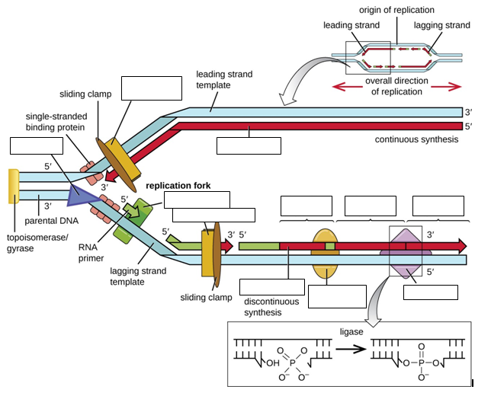

Check your understanding:

In what direction does DNA polymerase read the template DNA strands?

In what direction are the new DNA strands built?

What enzyme forms Okazaki fragments?

What enzyme joins Okazaki fragments?

Explain the relationship between the replication fork(s) and the replication bubble?

Why does DNA have to be replicated?

Part 2: Protein Synthesis

Review the process of protein synthesis (transcription and translation) from your classroom notes, textbook sections, or your instructor may play a video for you. Your instructor might also have you model the process using puzzles, models, or paperwork exercises. Use these activities to reinforce your understanding of the two steps (transcription / translation), as well as how they are affected by the Complimentary and antiparallel nature of DNA, and the rules of DNA – RNA base pairing.

SUMMARY Figure 2 (below). The making of a protein following the instructions encoded in DNA, via the processes of Transcription and Translation. DNA holds all of the genetic information necessary to build a cell’s proteins. The nucleotide sequence of a gene is ultimately translated into an amino acid sequence of the gene’s corresponding protein.
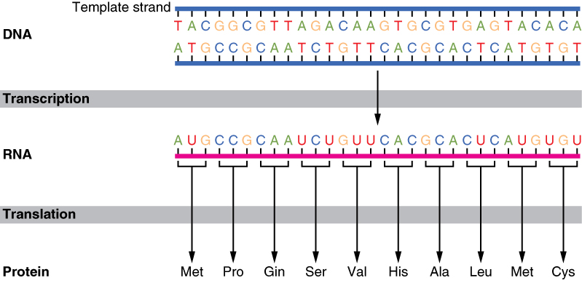

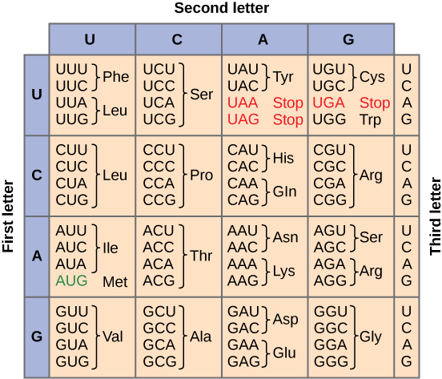
Figure 3 (at right). The Genetic Code for translating each nucleotide triplet, or codon, in mRNA into an amino acid or a termination signal in a nascent protein.

Use the following worksheet and the figure 3 (preview page) to explore the processes of protein synthesis:

Transcription
DNA non-template strand sequence: ____ ____ ____ ____ ____ ____ ____ ____ ____ ____ ____ ____
DNA template strand sequence: 3’ T A C C C A C G T C C A 5’

mRNA strand sequence: ___ ___ ___ ___ ____ ____ ____ ____ ___ ___ ____ ____

Separate the DNA template and the mRNA strands. In a cell, the mRNA strand would undergo some “editing” including the addition of the 5’ CAP, the 3’ poly-A tail, and removal of the introns. Then it would leave the nucleus, and the DNA strand would rejoin with its complementary half by reforming the hydrogen bonds between complimentary base pairs.

Translation

In the cell, the mRNA leaves the nucleus through a pore in the nuclear membrane. Once in the cytoplasm, it attaches to a ribosome and is “read” three base pairs at a time to determine the appropriate amino acid that should be inserted in the growing protein. A block of three consecutive nucleotides in the mRNA is called a codon. The ribosome (which is made of ribosomal RNA or rRNA) is comprised of two subunits named the 40S subunit and the 60S subunit (You can think of the “S” as a unit of weight measurement). The transfer RNA (tRNA) function to bring specific amino acids to the ribosome to be used in building the specific protein. Each tRNA has a three base sequence on one end called the anticodon and a sequence CCA on the other which serves as an attachment site for the tRNA’s specific activating enzyme. The activating enzyme is responsible for catalyzing the chemical reaction of joining the amino acid to the tRNA. The anticodon on the tRNA is complementary to the codon on the mRNA, which explains how the correct amino acid is brought to the site of translation.

Template DNA base sequence: 3’ T A C C C A C G T C C A 5’

mRNA codons: (5’ to 3’) ______ ______ ______ ______

tRNA anticodons: ______ ______ ______ ______

Amino acid sequence: ______ ______ ______ ______

6. In the previous lab on DNA replication, we discussed that errors can occur during the replication process. Typically, these errors are corrected by proofreading enzymes, but sometimes mistakes persist. A mistake that results in a single base change is called a point mutation and may affect the amino acid composition of the resulting protein.

a) How would the protein have been different if the DNA template sequence was T-A-C-C-G-A-C-C-T-C-C-G? Note: Use the table of the genetic code included earlier in this lab:

Template DNA base sequence: 3’ T A C C G A C C T C C G 5’

mRNA codons: (5’ to 3’) ______ ______ ______ ______

tRNA anticodons: ______ ______ ______ ______

Amino acid sequence: ______ ______ ______ ______

b) Do all point mutations cause a different amino acid to be inserted?

c) Notice from the table of the genetic code (included at the end of this lab) that 61 codons represent the 20 different amino acids. Why do you think it is advantageous, from a genetic perspective, to have this redundancy (i.e. the same amino acid is represented by more than one codon)?

7. Once translation is complete, the protein, the mRNA, and the two subunits of the ribosome separate. In a cell, the resulting protein would be passed into the endoplasmic reticulum where it would undergo further modifications before being used within the cell or exported to other locations within an organism.

8. If the base sequence on a template strand of DNA was TACTATGCCATT, what would be the sequence of the codons on the mRNA transcribed from this DNA?

5’ _____ _____ _____ _____ _____ _____ _____ _____ _____ _____ _____ _____ 3’

9. What would the sequence of bases of the anti-codons on the tRNA be?

_____ _____ _____ _____ _____ _____ _____ _____ _____ _____ _____ _____

10. What would be the sequence of amino acids that would be translated from this DNA?

_________ _________ _________ _________

11. If a mistake (point mutation) was made during replication of this strand so that the new DNA strand had the base sequence TACACAGCCATT, what would be the resulting change in the protein built from this strand?

_________ _________ _________ _________
12. Complete the following table using the information provided:

Non-Template DNA Strand | TAC
Template  DNA Strand |  |  |  | GGG
mRNA (5’ to 3’) |  |  |  |  | CCU
tRNA anti-codon |  | UCG
Amino Acid |  |  | Leucine

13. What is the difference, with respect to transcription, between the template and non-template DNA strands?

14. What are the DNA-DNA rules of complementary base pairing?

15. What are the DNA-RNA rules of complementary base pairing?

16. What are the RNA-RNA rules of complementary base pairing?

17. Distinguish between a codon and an anticodon. How are they similar? How are they different?

18. What are the functions of the mRNA, tRNA, and rRNA in translation.

19. In the genetic code table, three codons (UAA, UAG, and UGA) are associated with “STOP”. What does this mean with regards to translation?

More Practice:

Fill in the blanks – either the DNA sequence, the mRNA sequence, or the amino acid sequence.

- DNA 5’- G C A A T G G G T A C A C A A T G A C G -3’ Coding
3’- C G T T A C C C A T G T G T T A C T G C -5’ Template

mRNA ... _ _ _ _ _ _ _ _ _ _ _ _ _ _ _ _ _ _ _ _ -3’

- DNA
5’- G C A A T G G G T A C A C A A T G A C G -3’ Coding
3’- C G T T A C C C A T G T G T T A C T G C -5’ Template

mRNA ... _ _ _ _ _ _ _ _ _ _ _ _ _ _ _ _ _ _ _ _ -3’

Protein Met ___ ___ ___

- DNA
5’- G G A _ _ _ _ _ _ _ _ _ _ _ _ _ _ _ _ _ -3’ Coding
3’- _ _ T _ _ _ _ _ _ _ _ _ _ _ _ _ _ _ _ _ -5’ Template

mRNA 5’- G G A _ _ C G G G U G C A U U A A C C G ...

Protein Met ___ ___ ___

What are the components of a DNA nucleotide?

What are the four nitrogenous bases in DNA molecules?

What are the components of a RNA nucleotide?

What are the four nitrogenous bases in RNA molecules?

What are the percentages of thymine, cytosine and guanine in a DNA molecule that is 30% adenine?

What is meant by the “central dogma” of biology?

What are the effects of base substitutions on a protein?

What are the effects of an addition or deletion on a protein?

Where in a eukaryotic cell is DNA found?

Part D: Putting it all together

- In the diagram below state when each of these events occurs:
DNA Replication, Mitosis, Transcription, Translation, G1 checkpoint, G2 checkpoint, M checkpoint,

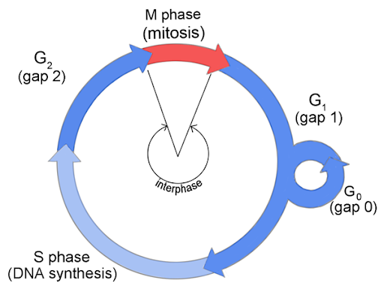
- State one major event that happens in each subphase and checkpoint.
- G1:

- G1 checkpoint:

- S phase:

- G2:

- G2 checkpoint:

- M:

- M checkpoint:

- Why does the M checkpoint need to happen before Anaphase?

